CATTIGAN CENTRE, EFAB Mall, Ahmadu Bello Way, Area 11,
P. O. Box 6488, Garki, Abuja - Nigeria.
Email: cattigancom@gmail.com | Tel: + 234 (0)803 311 6821

PROFORMA INVOICE No. 279 08 May 2024
RHSP/RCSDC

S/N | DESCRIPTION | UNIT COST (USD) | QTY | TOTAL (USD)
1 | Transportation of Reporters + Cameramen from Three (3) TELEVISION STATIONS invited to cover the Launching of RHSP project at Abuja Continental Hotel, Abuja, Nigeria on May 16, 2024 | $395 | 3 | $1,185
2 | Transportation of Heath Correspondents from Two (2) RADIO STATIONS to cover above event | $182 |   2 | $364
3 | Transportation of Heath Correspondents from Six (6) daily NEWSPAPERS invited to cover above event | $115 | 4 | $460
4 | Transportation of Correspondent from Eight (8) ONLINE NEWS PLATFORMS invited to cover above event | $100 | 6 | $600
 | Total media use |  |  | $2,609
5 | International Media (Optional) | xxx | xxx | xxx
6 | Multi-media outdoor (Optional) | xxx | xxx | xxx
7 | News Agency of Nigeria (Optional) | xxx | xxx | xxx
 | Agency fee (15%) for Coordination + Exigency BY CATTIGAN.COM |  |  | $391
 | Grand Total |  |  | $3,000

Amount in words: THREE THOUSAND US DOLLARS.
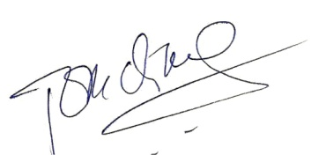

Tom Chiahemen
Principal Consultant/CEO

